**Error: Microsoft.Azure.WebJobs.Extensions.EventHubs: EventHub account connection string 'newhubneel_events_IOTHUB' does not exist. Make sure that it is a defined App Setting.**

Solution:

This type of error exists while connecting the azure iot hub or event hub to the azure functions, the main problem is due to the different naming conventions of the azure iot hub and the connection strings of the azure functions, and the main thing comes when we use the `-` in the naming of the azure IoT hub instance.



The function might have missed the connection string parameter reference during the deployment. You can address this by navigating to the configuration section of the Azure function on the cloud portal and add the application setting. Please refer the below image for more details.

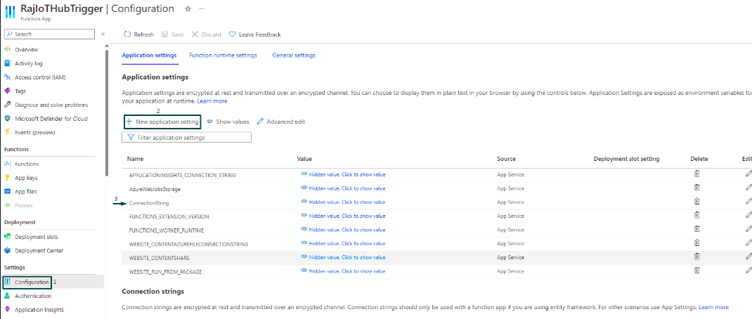

Make sure to name your application setting parameter as EventHub and provide the same endpoint value as used in your local.settings.json file. Note that no quotes are needed when you provide the key and value for the parameters.